**Assignment Day 4**

**Questions**

1. Find Out the mail servers of the following domain

Ibm.com

Wipro.com

2. Find the locations, where these email servers are hosted.

3. Scan and find out port numbers open 203.163.246.23

4. Install nessus in VM and scan your laptop/desktop for CVE.

**Question 1**

**Find Out the mail servers of the following domain**

**Ibm.com**

**Wipro.com**

**ibm.com**

Mail servers of ibm.com

mx0b-001b2d01.pphosted.com

mx0a-001b2d01.pphosted.com

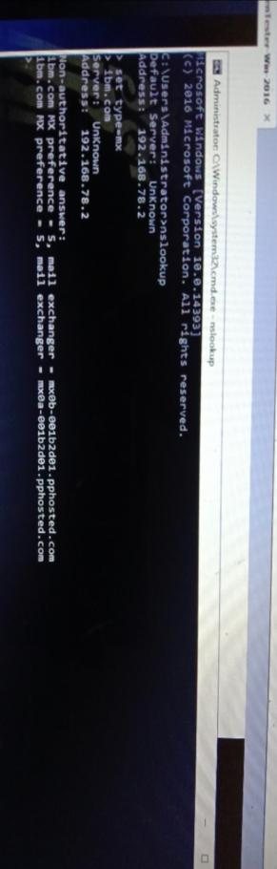

**Wipro.com**

Mail servers of Wipro

wipro-com.mail.protection.outlook.com

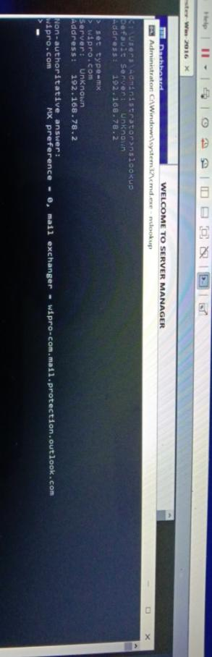

[**www.ibm.com**](http://www.ibm.com)

Mail server of [www.ibm.com](http://www.ibm.com)

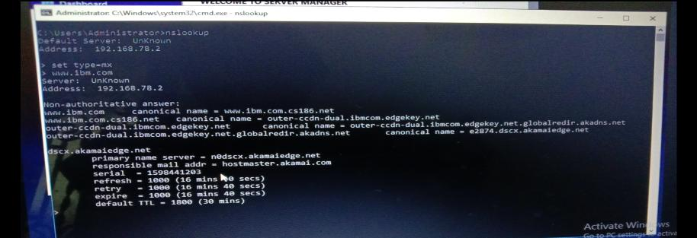 [**www.wipro.com**](http://www.wipro.com)

Mail server of [www.wipro.com](http://www.wipro.com)

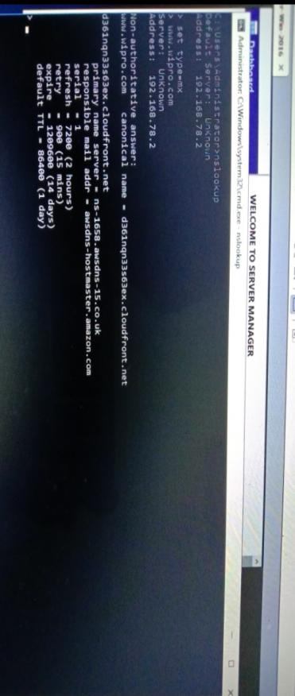

**Question 2**

**Find the locations, where these email servers are hosted**.

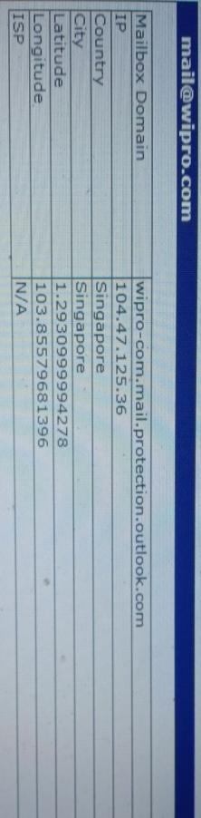**Ibm.com  
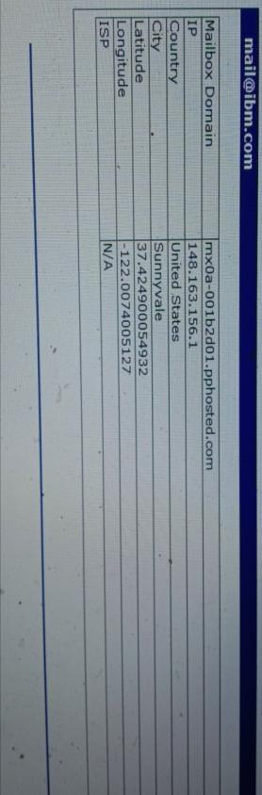  
wipro.com**

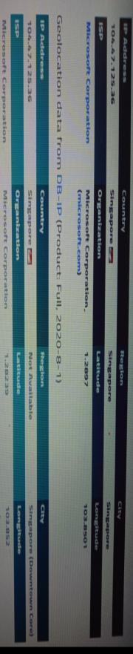[**www.ibm.com**](http://www.ibm.com)

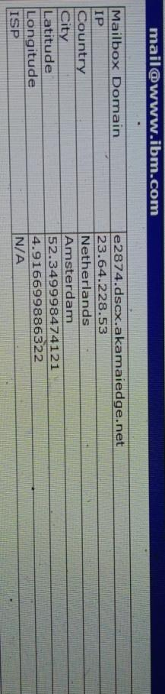[**www.wipro.com**](http://www.wipro.com)

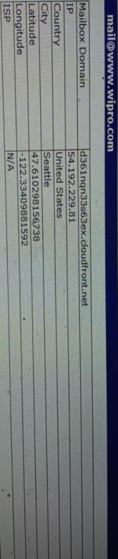

**Question 3**

**Scan and find out port numbers open 203.163.246.23  
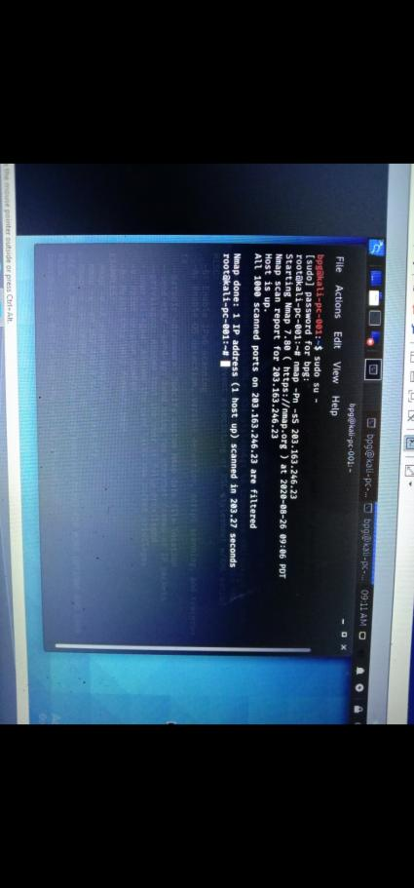  
  
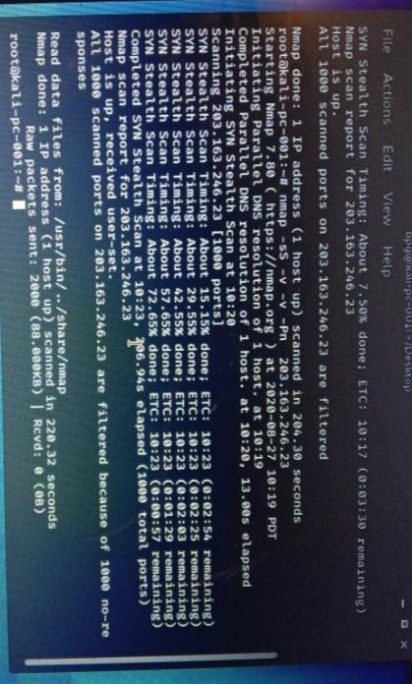**

**Question 4**

**Install nessus in VM and scan your laptop/desktop for CVE.**

Installed nessus and scanned for CVE

